CLDV6212

Part 1

Yadav Reginald Priaram

2024

Website url: <https://st10356506abc-c5haavbjg7eyeqcx.brazilsouth-01.azurewebsites.net>

Website screenshots

Customer list

File list

Upload file

Product list

Add new product

Publishing

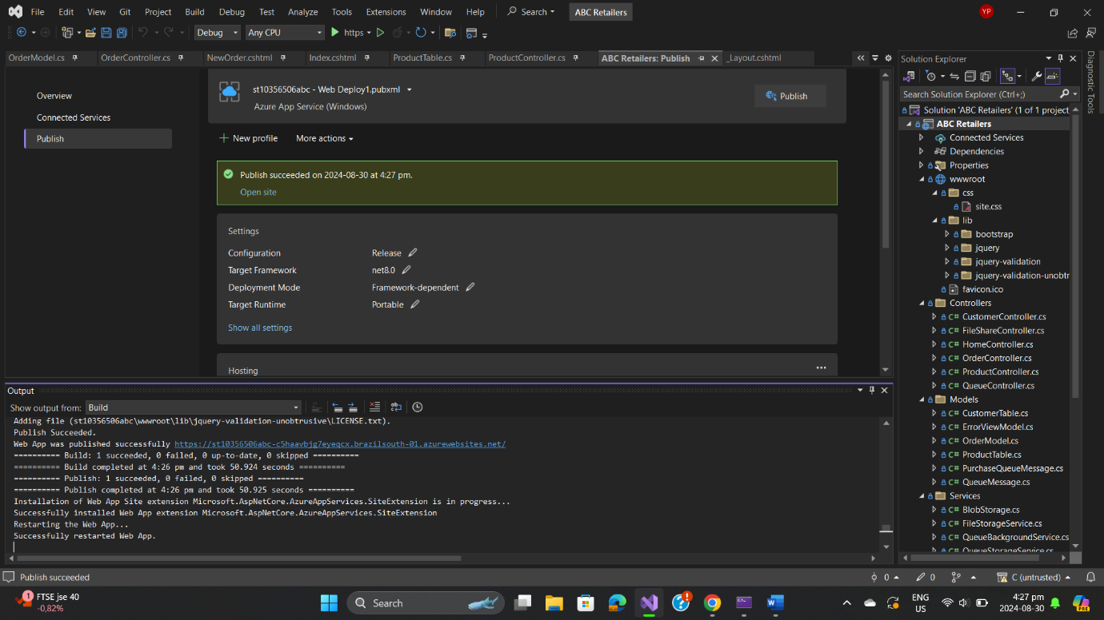

References (Code attribution):

<https://www.youtube.com/watch?v=SIBqRVJyQF0>

<https://youtu.be/vq3pzXv6kG0?si=v2eQ9YPgu1wucB0Y>

<https://learn.microsoft.com/en-us/visualstudio/azure/vs-azure-tools-connected-services-storage?view=vs-2022#:~:text=Open%20your%20project%20in%20Visual,Dependency%20page%2C%20select%20Azure%20Storage>.

<https://learn.microsoft.com/en-us/azure/azure-sql/database/connect-query-vscode?view=azuresql>

<https://stackoverflow.com/questions/74066764/visual-studio-c-sharp-connecting-azure-blob-and-fileshare-storage>

<https://www.w3schools.com/colors/color_tryit.asp?color=Azure>

<https://www.geeksforgeeks.org/microsoft-azure/>

<https://stackoverflow.com/questions/1317641/queue-based-background-processing-in-asp-net-mvc-web-application>

<https://learn.microsoft.com/en-us/azure/storage/queues/storage-tutorial-queues>

<https://stackoverflow.com/questions/60617190/how-do-i-store-a-picture-in-azure-blob-storage-in-asp-net-mvc-application>

<https://stackoverflow.com/questions/60617190/how-do-i-store-a-picture-in-azure-blob-storage-in-asp-net-mvc-application>

<https://stackoverflow.com/questions/29788540/how-to-share-files-between-multiple-asp-net-mvc-applications>

<https://www.c-sharpcorner.com/article/azure-storage-crud-operations-in-mvc-using-c-sharp-azure-table-storage-part-one/>